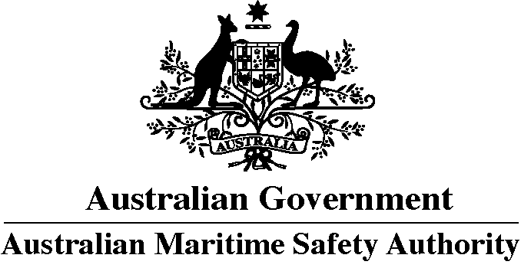
HARMFUL SUBSTANCES REPORT (POLREP)
Marine Order 91 (Marine pollution prevention – Oil)

To: General Manager, Response
through Joint Rescue Coordination Centre (JRCC) Australia
Telephone: +61 (0)2 6230 6811
Freecall: 1800 641 792 (within Australia)
AFTN: YSARYCYX
E-mail: rccaus@amsa.gov.au

Note: If any of the following items of the vessel reporting format are inappropriate they should be omitted from the report. These items of the standard reporting format are referred to in IMO Resolution A.851(20).
- Name of vessel Call sign Flag

- Date and time of event (Note: Time must be expressed as Coordinated Universal Time (UTC))

- Position: latitude and longitude or
- Position: true bearing and distance

- True course (as a three digit group)

- Speed (in knots and tenths of a knot as a 3-digit group)

- Route information – details of intended track

- Full details of radio stations and frequencies being guarded

- Time of next report (Note: Time must be expressed as Coordinated Universal Time (UTC))

- Type and quantities of cargo and bunkers on board

- Brief details of defects, damage, deficiencies or other limitations.
These must include the condition of the vessel and the ability to transfer cargo, ballast or fuel

- Brief details of actual pollution. These should include the type of oil, an estimate of the quantity discharged, whether the discharge is continuing, the cause of the discharge and, if possible, an estimate of the movement of the slick

- Weather and sea conditions, including wind force and direction and relevant tidal or current details

- Name, address, telephone and facsimile numbers of the vessel’s owner and representative (manager or operator of the vessel, or their agents)
Owner |  | Representative
Telephone | Facsimile | Telephone | Facsimile

- Type of vessel Length Breadth Tonnage

- 1. Action being taken with regard to the discharge and to the movement of the vessel

  - Assistance or salvage efforts which have been requested or which have been provided by others

  - The master of an assisting or salvaging vessel should report the particulars of the action undertaken or planned

