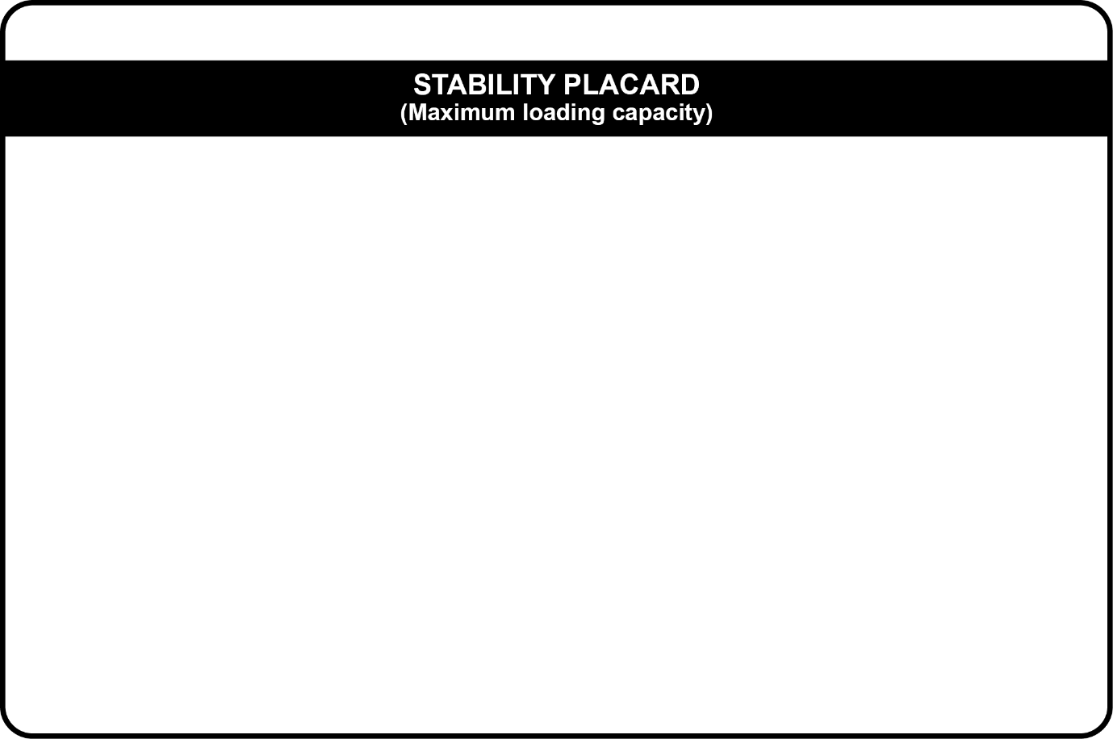

Maximum number of persons on board
Gross load capacity (persons + equipment/cargo + stores + fuel and water) | kg
Lightship displacement | kg
Maximum cargo and equipment vcg off the deck | m
Maximum cargo and equipment windage/centroid | m² @ m off the deck
Maximum wave height | m
Maximum wind speed | Knots
Maximum fuel capacity | L
Maximum engine mass | kg
Maximum allowable draft or freeboard | Freeboard: fwd aft
Type of buoyancy (choose appropriate type) | Choose an item.
Buoyancy volume | m³
Additional special limitations

