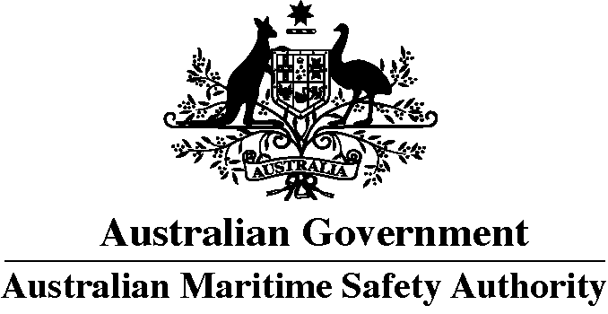

**Application for a Certificate of equivalence (AMSA 326)   
For service on ships registered in the Australian International   
Shipping Register (AISR) as required by marine order 2**

|  |
| --- |
| **This form is to be completed if you are applying for one or more of the following:**   * Certificate of equivalence * Re-issue of Certificate of equivalence |

Submitting this form does not immediately guarantee a Certificate of equivalence.   
The final decision with regard to the issue of a certificate is made by the Manager, Seafarer Certification Services.

**All supporting documents must be lodged with your application.**

**1. Eligibility criteria**

Applications for a Certificate of equivalence must be submitted on behalf of the Applicant by the ship owner, ship operator or crewing agent who has offered the applicant employment on a ship registered in the Australian International Ship Register (AISR).

The application form must be signed by the applicant.

Once AMSA has received a complete application and all requirements are met please allow at least 20 working days for your certificate to be issued. Assessment applications may take longer than this due to the process for AMSA to obtain verification of documents submitted or foreign qualifications held.

Application may be made by mail or in person at an AMSA office.

**2. Submitting the form**

The completed application, supporting documentation and fee may be sent to:

**Postal address**

Australian Maritime Safety Authority  
Shipping Qualifications  
GPO Box 2181  
Canberra, ACT 2601, AUSTRALIA

**Courier address**

Australian Maritime Safety Authority  
Shipping Qualifications  
18 Marcus Clarke Street  
Canberra, ACT 2601, AUSTRALIA

**3. Fee payment methods**

Read Schedule of charges for international certificates: [www.amsa.gov.au/scheduleofcharges](http://www.amsa.gov.au/scheduleofcharges).

The fee must be included when the application is submitted.

**Payment options**

1. Bank draft/cheque: make payable in Australian dollars to Australian Maritime Safety Authority. Write your name and reason for payment on the back of bank draft/cheque.
2. Credit card—VISA or MasterCard only: Please complete Seafarer certification credit card payment authorisation form 161: [www.amsa.gov.au](http://www.amsa.gov.au)/seafarerpayment

Do not mail cash with this application form as it is illegal.

**4. Returning your certificate**

If required your certificate can be returned to you by courier. An additional fee of A$80 is charged for this service.

**5. Proof of identity**

When making an application for a Certificate of equivalence you must include a copy of your current passport.

Proof of identity is required to apply for a marine qualification to protect your identity and the qualification/licence system.

**6. Photograph**

You must attach two recent colour passport photographs of yourself on page 1 of the Application form.

The photograph must comply with all of the following requirements. If not, your application will be returned and a new photograph will be required—this will delay the issue of the certificate.

The photograph must be:

a. Between 35–40mm wide and 45–50mm high. The head of the application must take up 32–36mm of the photo (see diagram).

b. Good quality colour and on a photo-quality paper, with no ink or marks on the image.

c. On a plain, light coloured background with no shadows.

d. Appropriately bright with enough contrast to accurately show applicants skin tones naturally.

e. Taken with no shadows across the face.

f. Clear and in sharp focus.

g. Of the applicant’s head and top of shoulders (see diagram).

h. Showing the applicant looking straight at the camera and head not tilted— both edges of the face should be visible.

i. Taken with a natural expression—not laughing or frowning—with applicants mouth closed.

j. Showing the eyes open and eye colour clearly visible. If glasses are worn, ensure there is no reflection in the lenses.

k. Showing the applicant with no hat or head covering. Head covering is acceptable if worn for religious reasons however the facial features from the bottom of the chin to top of the forehead and both edges of the face must be clearly shown.

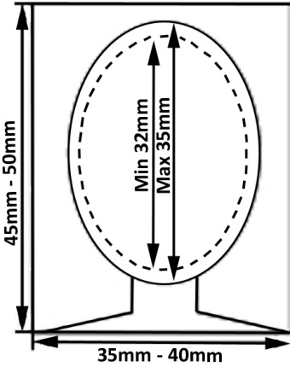

**7. Signature**

Your signature on page 1 of the Application form must fit within the box provided without touching the edges of the box.

If your signature does not fit within the box it cannot be transferred to your certificate and you will be required to lodge another fully completed application form.

Practice your signature below:

|  |
| --- |
|  |

**8. Medical certificates**

In Australia:

Applicants living, working or currently in Australia must include a current copy of your Certificate of medical fitness for international certificates form 303 ([www.amsa.gov.au/](http://www.amsa.gov.au/)medicalfitness) issued by an AMSA approved Medical inspector.

Outside of Australia:

Applicants not living or working in Australia must include a copy of your current Certificate of medical fitness issued by a doctor approved by a Marine Administration whose seafarer qualifications are recognised by AMSA. The doctor must conduct the medical examination as required by the Medical examination report form 232 ([www.amsa.gov.au/medical-examination-report](http://www.amsa.gov.au/medical-examination-report)). The doctor must issue a certificate using the Certificate of medical fitness for international certificates form 303 ([www.amsa.gov.au/](http://www.amsa.gov.au/)medicalfitness).

Do not include:

X-rays or other medical documents with this application. These are not required.

Current marine order:

Refer to the current issue of marine order 76: [www.amsa.gov.au/mo76](http://www.amsa.gov.au/mo76).

**9. Special training requirements for certain types of ships**

A Certificate of equivalence or Interim certificate of equivalence will not be valid for service on oil tankers, chemical tankers, gas carriers, passenger ships including ro-ro passenger ships, unless the primary Certificate of Competency contains the appropriate STCW endorsement (Reference STCW Code, Chapter V – Standards regarding special training requirements for personnel on certain types of ships).

**10. Provide proof of competency in written and spoken English**

Evidence of satisfactory competency in English language can be demonstrated by one or more of the following:

• Hold a STCW Certificate of competency for which the examinations were conducted in English.

• Passing the Marlins test at an approved Marlins test centre.

• Passing an English language assessment approved by the Manager Ship Operations and Qualifications.

For service on a ship registered in the AISR the minimum acceptable pass mark that must be achieved on the Marlins test is:

Senior Deck Officers 90%

Senior Engineer Officers 80%

Junior Deck Officers 80%

Junior Engineer Officers 70%

Ratings 60%

The above evidence must be accompanied by evidence that the employer is satisfied that the seafarer has an acceptable standard of English that will enable them to carry out their shipboard duties safely.

**11. Global distress and safety system (GMDSS) general operators certificate of recognition**

Unless already held, masters and mates applying for a Certificate of equivalence must also apply for either an AMSA GMDSS General operators certificate or GMDSS General operators certificate of recognition.

The application must be made using Seafarer form 419 Application for a Certificate and/or Endorsement (www.amsa.gov.au/419). This application form must be attached to the application for a Certificate of equivalence.

**12. Assessment in Australian maritime regulatory framework**

There is information on the AMSA web site on how to undertake an assessment in Australian maritime regulatory framework.

**13. Dispatch**

A Certificate of equivalence or Interim certificate of equivalence will only be sent to the ship owner, ship operator or crewing agent who submitted the application on behalf of the applicant.

The ship owner, ship operator or crewing agent must ensure that applicant receives the certificate prior to joining the vessel.

**A – Personal details**

|  |  |  |  |  |  |  |  |  |  |  |  |  |
| --- | --- | --- | --- | --- | --- | --- | --- | --- | --- | --- | --- | --- |
| Seafarer ID | | |  | | Date of birth | | | | | | | |
|  | | |  | | D | D | M | M | Y | Y | Y | Y |
|  | | |  | |  |  |  |  |  |  |  |  |
| Full name | | |  | |  | | | | | | | |
| Mr  Mrs  Ms  Miss  Mx  Other: | | | | | | | | | | | | |
|  | |  | | |  | | | | | | | |
| Family name* | | | | | | | | | | | | |
|  | |  | | |  | | | | | | | |
| Given name(s) | | | | | | | | | | | | |
|  | |  | |  | | | | | | | | |
| Nationality | |  | | Are you an Australian citizen or resident? | | | | | | | | |
|  | |  | | Yes  No | | | | | | | | |
|  | |  | |  | | | | | | | | |
|  | |  | |  | | | | | | | | |
| Gender | | | | | | | | | | | | |
| Male  Female  Indeterminate | | | | | | | | | | | | |
|  | | | | | | | | | | | | |
| Applicant’s permanent address (for contact) | | | | | | | | | | | | |
| House number | Street | | | | | | | | | | | |
| Town or Suburb | | | | | | | | | | | | |
| District or state | | | | | | | | | | | | |
| Postcode | Country | | | | | | | | | | | |
| Telephone number | | | | | | | | | | | | |
| Email address | | | | | | | | | | | | |
|  |  | | | |  | | | | | | | |
| Delivery address (Company who submitted application) | | | | | | | | | | | | |
| House number | Street | | | | | | | | | | | |
| Town or suburb | | | | | | | | | | | | |
| District or state | | | | | | | | | | | | |
| Postcode | Country | | | | | | | | | | | |
| Telephone number | | | | | | | | | | | | |
| Email address | | | | | | | | | | | | |
|  |  | | | |  | | | | | | | |

* Your family name will appear **after** your given names on your certificate

**B – Certificate currently held**

|  |  |  |
| --- | --- | --- |
| Grade of certificate | | |
|  | | |
|  |  | |
| Sub-grade of certificate |  | Certificate number |
|  |  |  |
|  |  |  |
| Country of issue |  | Date of issue |
|  |  |  |

**C – Supporting documentation attached**

Copy of certificate of competency / licence or rating certificate

Copy of AMSA Global Maritime Distress and Safety System (GMDSS) General operators certificate or application for GMDSS Certificate of recognition (Master and Mates only) (See note 11—information cover sheet)

Copy of passport (See note 5—information cover sheet)

Copy of AMSA Certificate of medical fitness   
 (See note 8—information cover sheet))

Evidence of English competency, including evidence from company (See note 10—information cover sheet))

Offer of employment (See note 1—information cover sheet))

**C1 – For Deck and Engineer officers only**

Evidence of having passed an assessment in Australian maritime regulatory framework (See note 12)

**D – Applicant’s signature and photograph**

|  |  |  |
| --- | --- | --- |
| Please use a black pen and make sure that your signature fits inside the box. (See note 5—information cover sheet) |  | **Photograph**  Attach two passport size photographs  (see note 6—information cover sheet)) |
|  |
|  |

**E – METHOD OF LODGEMENT**

|  |  |  |  |
| --- | --- | --- | --- |
| Application mailed  Application submitted in person | Port of lodgement |  | Date received/submitted |
| If application mailed you must attach a current copy of your identification as per note 5—information cover sheet. | | | |
| Do you require your certificate to be returned to you by courier?  No  Yes – If Yes. A courier fee of A$80 is required. | | | |

**F – Declaration**

|  |  |
| --- | --- |
| **WARNING: Giving false or misleading information is a serious criminal offence and may lead to prosecution.** | |
| To the best of my knowledge, the information given by me in this application is true and correct in every detail | / / 20  *Signature of applicant Date* |
| **Submitting this form does not immediately guarantee a Certificate of equivalence. The final decision for the issue of a certificate is made by the Manager, Seafarer Certification Services.** | |
| **PRIVACY STATEMENT**  The Australian Maritime Safety Authority (AMSA) is collecting the information on this form to determine if you are eligible for a Certificate or Interim Certificate of equivalence. This is authorised by the *Navigation Act 2012* (the Act) and the marine orders made under it. The information will be used for purposes related to the Act and marine orders and will be treated in accordance with the Australian Privacy Principles. AMSA may give some or all of this information, including information concerning the validity, cancellation, imposition of restrictions or suspension of certificates to overseas marine administrators, ship owners, operators, agents, the Australian Communications and Media Authority and law enforcement agencies as required by law. Failure to provide the information may result in the transaction not being processed.  To contact us, or for more information on how to access or correct your personal information, how to make a privacy complaint, or how your information may be used or disclosed, visit AMSA’s privacy policy at [www.amsa.gov.au/privacy](http://www.amsa.gov.au/privacy) | |