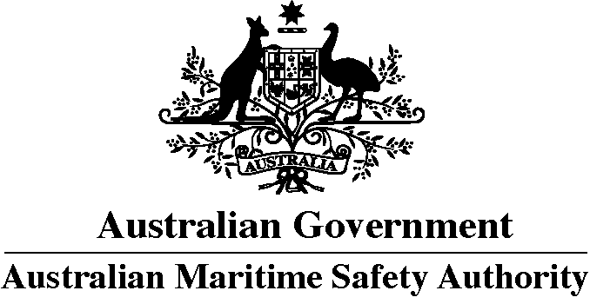
HARMFUL SUBSTANCES REPORT (POLREP)
Marine Order 93 (Marine pollution prevention – noxious liquid substances)

To: General Manager, Response
through Joint Rescue Coordination Centre (JRCC) Australia
Telephone: +61 (0)2 6230 6811
Freecall: 1800 641 792 (within Australia)
AFTN: YSARYCYX
E-mail: rccaus@amsa.gov.au

Note: If any of the following items of the vessel reporting format are inappropriate they should be omitted from the report. These items of the standard reporting format are referred to in IMO Resolution A.851(20), as amended by MEPC.138(53).
- Name of vessel Call sign Flag

- Date and time of event (Note: Time must be expressed as Coordinated Universal Time (UTC))

- Position: latitude and longitude or
- Position: true bearing and distance

- True course (as a three digit group)

- Speed (in knots and tenths of a knot as a 3-digit group)

- Route information – details of intended track

- Full details of radio stations and frequencies being guarded

- Time of next report (Note: Time must be expressed as Coordinated Universal Time (UTC))

P.
Type of oil or the correct technical name for the noxious liquid substances on board | UN number or numbers, if available
Pollution category (X,Y or Z) for each noxious liquid substance
Names of manufacturers of substances or consignee or consignor | An estimate of the quantity of the substances

Q. Brief details of defects, damage, deficiencies or other limitations.
These must include the condition of the ship and the ability to transfer cargo, ballast or fuel

R.
Type of oil or the correct technical name for the noxious liquid substance discharged into the sea |  |  | UN number or numbers if available
Pollution category (X,Y or Z) for each noxious liquid substance
Names of manufacturers of substances or consignee or consignor
An estimate of the quantity of the substances | Whether the substances floated or sank | Whether loss is continuing
Cause of loss
Estimate of the movement of the discharge or lost substances giving current conditions, if known
Estimate of the surface area of the spill

- Weather and sea conditions, including wind force and direction and relevant tidal or current details

- Name, address, telephone and facsimile numbers of the vessel’s owner and representative (manager or operator of the vessel, or their agents)
Owner |  | Representative
Telephone | Facsimile | Telephone | Facsimile

- Type of vessel Length Breadth Tonnage

- 1. Action being taken with regard to the discharge and to the movement of the vessel

  - Assistance or salvage efforts which have been requested or which have been provided by others

  - The master of an assisting or salvaging vessel should report the particulars of the action undertaken or planned

